3/27/2025
Moiz Ansari [23i-0523]

Cricket Match Analysis Tool with Scheduling Algorithms
Operating System Assignment 2 (Q-3)
Table of Contents
Method of Data Calculation 2
Screenshots 2
Bowlers 3
Batters 4
Predicted Run Scores and Wickets 4
Bowlers 4
Using RR 4
Using SJF 4
Batters 5
Using SRTF 5
Using SJF 5
Comparison of Each Scheduling Strategy 5
Bowlers 5
Using RR 5
Using SJF 6
Batters 6
Using SRTF 6
Using SJF 6
Recommendations 6
Bowlers 6
Batters 6

Method of Data Calculation
- The data was imported from a CSV file and calculated in the C++ code.
- Then it was again updated on the original CSV file.
- Each player’s separate data was also updated on their separate CSV files.

Screenshots
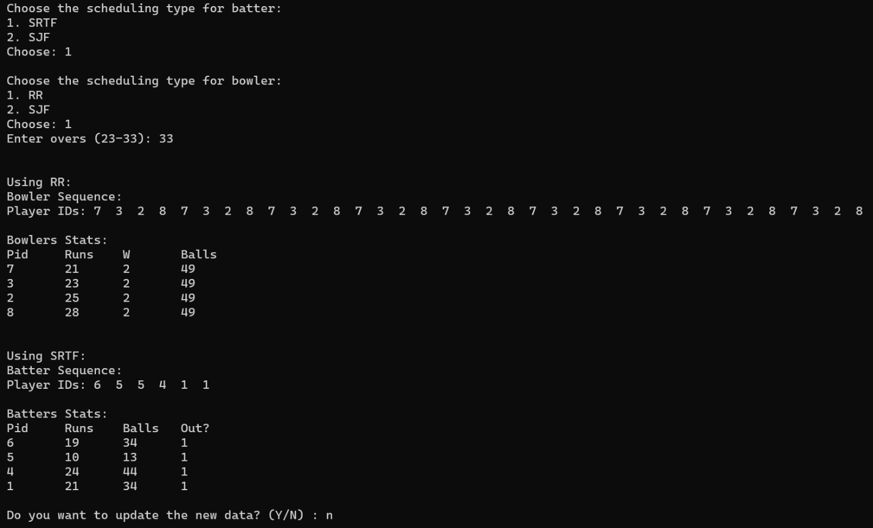
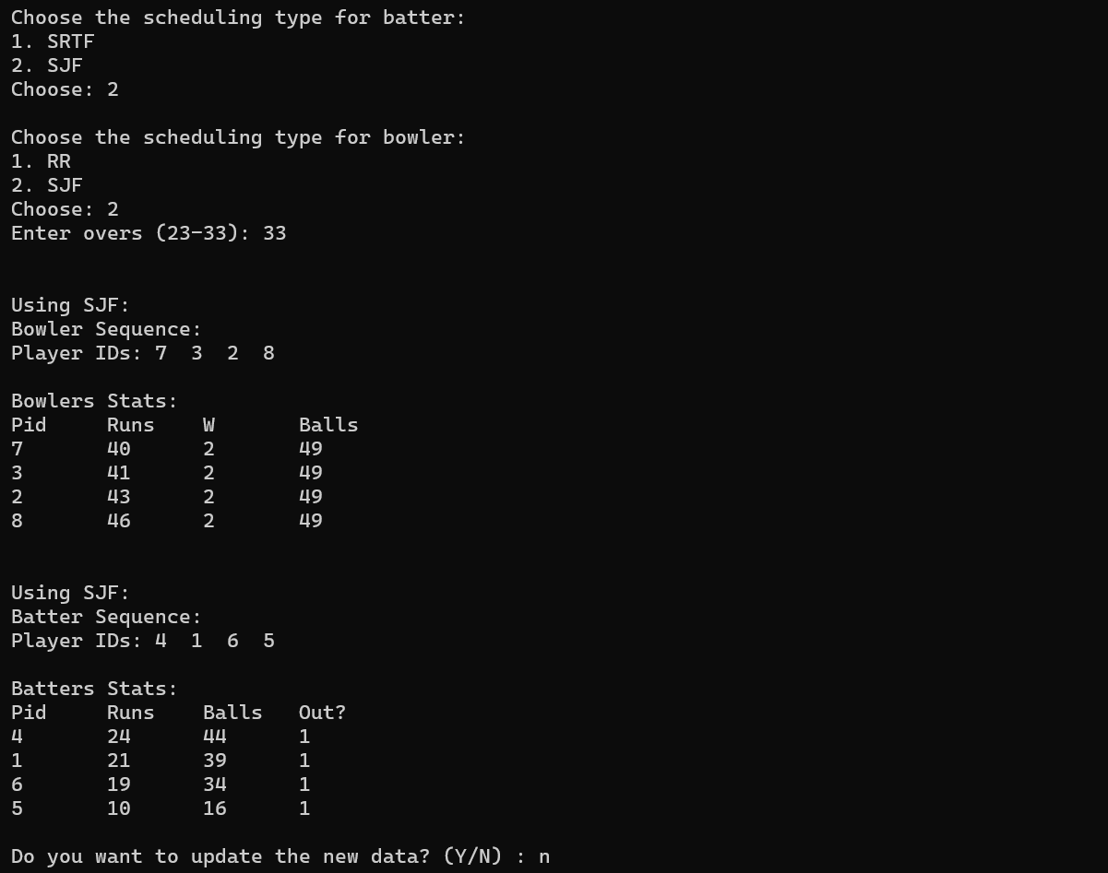

Bowlers
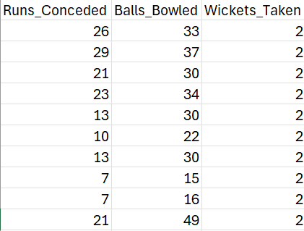

Batters
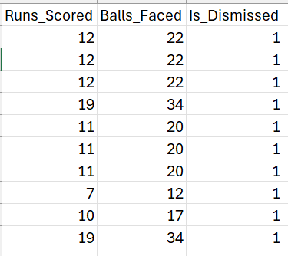

Predicted Run Scores and Wickets

Bowlers

Using RR
Bowler Sequence:
Player IDs: 7 3 2 8 7 3 2 8 7 3 2 8 7 3 2 8 7 3 2 8 7 3 2 8 7 3 2 8 7 3 2 8 7 3 2 8
Bowlers Stats:
Player ID | Runs Conceded | Wickets Taken | Balls Bowled
7 | 21 | 2 | 49
3 | 23 | 2 | 49
2 | 25 | 2 | 49
8 | 28 | 2 | 49

Using SJF
Bowler Sequence:
Player IDs: 7 3 2 8
Bowlers Stats:
Player ID | Runs Conceded | Wickets Taken | Balls Bowled
7 | 40 | 2 | 49
3 | 41 | 2 | 49
2 | 43 | 2 | 49
8 | 46 | 2 | 49

Batters

Using SRTF
Batter Sequence:
Player IDs: 6 5 5 4 1 1
Batters Stats
Player ID | Runs Scored | Balls Faced | Out? | Strike Rate
6 | 19 | 34 | 1 | 62.5
5 | 10 | 13 | 1 | 55.88
4 | 24 | 44 | 1 | 53.84
1 | 21 | 34 | 1 | 54.54

Using SJF
Batter Sequence:
Player IDs: 4 1 6 5
Batters Stats
Player ID | Runs Scored | Balls Faced | Out? | Strike Rate
4 | 24 | 44 | 1 | 65.21
1 | 21 | 39 | 1 | 65
6 | 19 | 34 | 1 | 68.75
5 | 10 | 16 | 1 | 75

Comparison of Each Scheduling Strategy

Bowlers

Using RR
The players keep changing their turns after each over, so they keep up their efficiency and do not get exhausted. That’s why their runs conceded per ball remain constant.

Using SJF
The players bowl constantly until all their specified number of balls are finished. This reduces their efficiency as they get exhausted bowling constantly.

Batters

Using SRTF
The batters with the shortest number of balls left are brought on strike first because they are in their form. This leads to an increase in their performance, and they score their target runs in a smaller number of balls, increasing their strike rate.

Using SJF
The batters who have the highest strike rate are brought on strike, and they play until they are dismissed.

Recommendations

Bowlers
For bowlers, it is recommended to use Round Robin, as this allows their runs conceded per ball constant, and maintains their efficiency.

Batters
For batters, the Shortest Remaining Time First is recommended, as the players in good form will perform first and score more in a smaller number of balls, increasing their strike rates and improving their career statistics.

